Gas pipeline monitoring system in hospital

***Abstract* - As we know Industrial security has been major issue in present scenario. The numbers of accidents are increasing day by day and we have seen many examples in our day life about those accidents that are being occurred due to combustible gases. Frequently we also hear, explosion of household cylinder which are used for domestic purpose, for vehicles and in many industries. In some situation many people have been injured severely and also several got dead because of explosion. So we are making this work for security and alerting peoples or specially workers those working on that environment to save their lives. The aim of this work is to detect gas leakage in the pipeline through GSM connectivity and monitoring it with mobile app. In the proposed system, the robot keeps moving along the pipe and keeps monitoring for any gas leakage, on detection it send data to mobile app via GSM. It is automated with ultrasound like a robot that moves with the gas pipe and detects gas leakages instantly at the real time. This system may be used in industrial applications for detecting pipeline leakages with large size kit. This system consists of gas detection using Raspberry pi and real time monitoring on web via GSM.**

***Keywords: Raspberry PI3, Ultrasound sensor, Gas Sensor, Gas pipes, GSM.***

1. INTRODUCTION

The source of economy for most countries in the world are gas, oil, and water. Their natural resources are transported from there storage place to the countries through the pipelines. In some of the countries, pipelines are used for supplying gas. These pipelines are the major source between the producers and consumers and at the same time Maintaining their pipelines is very costly. For human being its really hard to find the exact position of leakage on pipe area These locations locate by Robot with help of altitude and latitude concept send that data to user or operator and finds the exact location. Thus user will OFF the switch and can

avoid a future accident. These are essential to political stability, sustain economic growth and also safety [1].

The emergence of new high speed technology and growing computer capacity provides realistic opportunity for new robot controls and realized the new methods of control theory. This technical improvement in the robots created faster, accurate and more intelligent robots using new robots control devices, new drivers and advanced control algorithms. This paper draws a new economical solution of robot control systems. The introduced robot control system can be used for different sophisticated robotic applications.

The gas main distribution method [2] is taken place through the pipeline; however, several problems related to the use of wireless sensors in pipeline monitoring system are discussed. One of the problem is to detect the gas leakage in the pipeline as early as possible particularly in a gas pipeline. It is very important to detect the leakages in the pipeline as early as possible. If the detection of the gas leakage in the pipeline fails it could cause some serious issues in the environment and it also effects the human population near the area. Due to the structural defects corrosion occurs in the gas pipeline. Several factors have been identified that lead to the event of buried pipeline corrosion and cracks such as pipe coatings, soil type, temperature changing, stresses, pressure of the pipe and cyclic loading effects LPG consists of a mixture of gases like propane and butane. And here the robot will sense the leakage of the gas with the help of the gas sensor MQ135. The sensitivity is depend upon sensor conductivity and concentration of the gas so it may detect not only combustible gas but also smoke, butane, isobutene, After sense Gas PI3 will detect and send these signal to monitoring system through GSM. Thus, a gas detector is invented to easily detect

the presence of those dangerous gases within an area to prevent any disaster happen. The gas detector is a gas detecting device that used to be applied in dangerous place. To design such a detector, a gas sensor (MQ-135 LPG gas sensor), controller, are required. The MQ-135 sensor uses Tin Dioxide as the sensing material and as is highly sensitive to Propane and Butane gas and less sensitive to other gases like carbon monoxide and smoke.

The success of designing the LPG gas leakage detector will help to efficiently detect the leakage of LPG gas and avoid risk of fire and pollution, saving life and property. In oil and gas industry, a gas leak is hazardous to personnel and industrial operation. A quick detection and alert would minimize the dangers of gas leak [1]. Nowdays, Wireless technologies are used in many areas and it was used in many applications and several technologies are implemented for monitoring the pipelines. Many system are used in locating the place where leakages occur. Some of the technologies allow some remote system to identified leakage or detect and to report the positions of any leakage to the operator. This paper presents the implementation of a wireless gas leakage monitoring system by using Raspberry Pi and monitoring on web through GSM.

1. LITERUTER SURVEY

Mukesh Mahajanand Vishal Date [2] expressed the system which detects the gas leakage and can be monitor on IOT. Ch. Manohar Raju [3] describe robot technology here the mini robot finds the leakage in insecure places. Here author developed android mobile app which will receive information from many robot directly using Bluetooth. The disadvantage of the system is that before practically used in industrial area more setting and development is needed in detection and indication on mini robot simulation.

A Mahalingam [4] introduced design and implementation of economically suitable gas leakage detection system. The system ensures a continuous monitoring and checking the gas level and detection. This system is applicable only for restricted area where leakage is found or occurs. Beyond that, this system is not applicable.Zhao Yang [5] researched on leakage detection in gas pipeline system. To obtain the data from pipeline SCADA system is used for communication. Aashish Srivasthava [6],proposed a gas leakage detection system with the help of MQ6 gas sensor which detects LPG gas and sends the signal to microcontroller. The drawback here is that the microcontroller used is memory inefficient. Sagar Shinde [7], proposed the system real time detection of potential risk area, collect the data of leak accident and locate leakage point. This system is having protection circuitry consist of exhaust fan and LPG safe solenoid valve. MQ6 gas sensor is

used to detect LPG gas leakage. The disadvantage of the system is that it can only detect leakage of LPG and propane gas. Madhura Ghule [8] proposed a paper on LPG level monitoring, booking and gas leakage detector, the proposed system helps in recognition, checking and control arrangement of LPG spillage. The gas sensor MQ6 is used which mainly detects LPG and buzzer alert system is used. Manaswi Sharma [9] proposed a system detects gas leakage using a sensor and immediately turn-off the regulator knob to stop further leakage. A wifi module sends SMS or e-mail using the cloud to the user. Anandhakrishna S [10] proposed an SMS based gas leakage alert system. Gas sensor are used to detect gas leakage in a kitchen. With the help of an infrared sensor the issue of gas wastage is also monitored. An alarm goes off whenever the sensor does not detect any vessel over the burner beyond a particular time period. Sjeya Anusuya [11] proposed an innovative robot that lings on to the outer surface of the gas pipe and moves with the pipe to check for leakages. The kit consists of MQ2 gas sensor to detect the gas leakages. The robot will be moving continuously along the metal pipe, if there any presence of leakage the GPS sensor module will transmit the location to the cloud. Dr. S P Rajaram [12] they expressed about IoT based gas pre booking and gas leakage detection using IBM server. Detection and transmission and receiving module are the two important modules in the proposed system. The outcome was security level of home can be increased by detecting gas leakage and sending an alert. Ms. Fariha Aimen [13] proposed a system based on image processing where SF6 gas leakage is detected. Since SF6 gas and air have different infrared absorption properties, it is easy to observe SF6 gas that leaks into the air through infrared imaging detection technique but this system could detect only one gas.

1. METHODOLOGY

In this section, the methodology procedures divided into two parts. All parts were assembled to accomplish the function of detecting gas leakage. The first part is a hardware implementation of the used parts, while the second is the software design details.

1. *Hardware Implementation*

There are several parts of electronics that help in developing Gas Leakage Detection Robot such as sensors, Raspberry PI3, DC motors, Motor driver. Figure 1 shows the block diagram of Gas Leakage Detector Insect Robot which consists of input of MQ-135 gas sensor, ultrasonic sensor, Raspberry PI 3, DC Motor, Motor Driver (L298N) and GSM Module for communication.

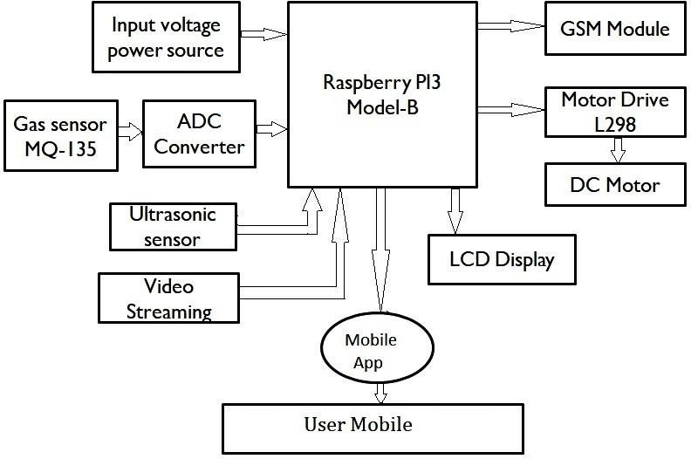Figure1. Gas pipeline monitoring system

1. *Raspberry Pi-3 Model B*

Raspberry Pi is a small single board computer as shown in figure 2. By connecting peripherals like Keyboard, mouse, display to the Raspberry Pi, it will act as a mini personal computer. Raspberry Pi [15] is popularly used for real time Image/Video Processing, IoT based applications and Robotics applications.For the physical computation, Raspberry has provided the GPIO (General Purpose Input Output) pins. These pins are like those standard input output pins which were dedicated in your personal computer for standard devices like Mouse and Keyboard etc. This GPIO module has made Raspberry unique from other computer devices. This inspiration makes raspberry Pi more than enough to drive the Internet of Things (IoT) concept into the reality. Raspberry is a microprocessor which requires an operating system to deal with it. Raspberry Pi officially provides Debian based Raspbian OS (Operating System). Also, they provide NOOBS (New out of the Box Software) OS for Raspberry Pi. We can also install various other Third Party versions of OS like Ubuntu, Arch Linux, RISC OS, Windows 10 IOT Core, etc. Raspbian OS is a official Operating system available for free to use. This OS is efficiently enhanced to use with Raspberry Pi. Raspbian have GUI which includes tools for Browsing, Python programming, office, games, etc. We should use SD (Secure Digital) card (minimum 8 GB recommended) to store the OS. Raspberry Pi is much more than computer as it provides access to the on-chip hardware.

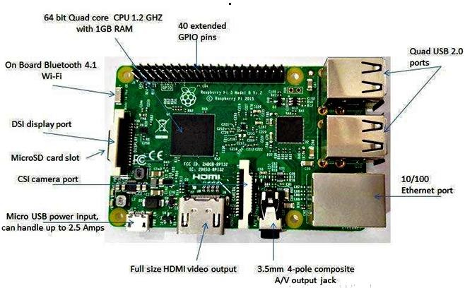

Figure 2. Raspberry Pi 3 board configuration

1. *DC Motor*

DC motor as shown in figure 3 uses Direct Current (electrical energy) to produce mechanical rotational movement. When it converts electrical energy into mechanical energy then it is called as DC motor[14] and when it converts mechanical energy into electrical energy then it is called as DC generator. The working principle of DC motor is depends on the fact that when a current carrying conductor is placed in a magnetic field, it experiences a mechanical force and starts rotating. Its rotation direction depends upon Fleming’s Left Hand Rule.

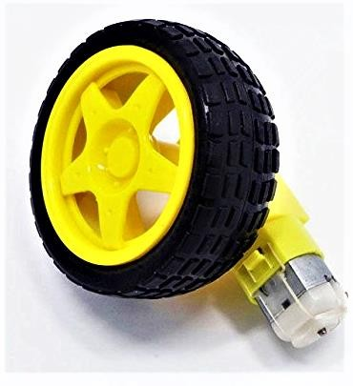

Figure 3: DC motor with wheel

The figure 3 shows dc motor that is used to create movement of the robot. In this system, two dc motors are used and can be driven by PI3 via motor driver module.

1. *Motor Drive Module*

PI cannot drive the dc motor directly. The current and voltage levels are not matched with controller and dc motors. So motor driver is provided to drive the motor by PI3. The L298N shown in figure 4 is an integrated monolithic circuit in a 15 lead multiwatt and PowerSO20 packages. Because it is a high current, high voltage dual full-bridge driver which is designed to accept standard TTL logic level sand drive inductive loads such as DC, stepping motors, relays, solenoids. Two enable inputs are provided to active or deactive the device independently of the input signals. In each bridge the emitters of the lower transistors are connected together and the respective external terminal can be used for the connection of an external sensing resistor. An additional supply input is provided so that the logic works at a lower voltage.

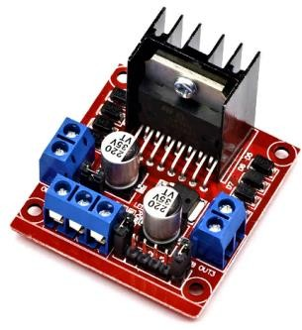

Figure 4: L298 Driver Module

1. *MQ-135 Sensor*

MQ-135 gas sensor is used in this system as shown in figure

6. The MQ-135 Gas sensor can detect or measure gasses like Alcohol, Ammonia(NH3), Nitrogen oxide (NOx), Benzene(C6H6), and Carbon dioxide(CO2) gases. The module version of this sensor comes with a Digital Pin which makes it to operate even without a microcontroller and that comes in handy when you are only trying to detect one particular gas. When we are measuring the gas in ppm the analog pin has to be used, the analog pin is TTL driven and works on 5V and hence can be used with most common microcontrollers. Using an MQ sensor it detects a gas is very easy. Simply power the module with 5V and you should notice the power LED on the module to glow and when no gas it detected the output LED will remain turned off meaning the digital output pin will be 0V. Now, introduce the sensor to the gas you want to detect and it should be seen the output LED to go high along with the digital pin, if not use the potentiometer until the output gets high. Sensor can be introduced to this gas at this particular concentration the digital pin will go high (5V) else will remain low

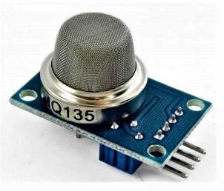

Figure 5: MQ-135 Sensor

4. *Ultrasonic sensor:*

One of the most critical electronic parts that provide a very low-cost and easy method of distance measurement as shown in Fig. 6. It used to detect and measure the distance to targets in many automated factories and process plants. To identify the presence of objects sensors with an on or off digital output is required, while sensors with an analog output which varies proportionally to the sensor to target separation distance are commercially available. The HC- SR04 ultrasonic sensor has a range of 2 cm to 400 cm with an angle of 15 degrees.

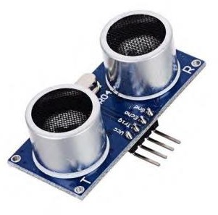

Figure 6: Ultrasonic sensor

1. *Software Implementation*
   1. *Raspbian OS*

Raspbian is a free operating system based on Debian introduced for the Raspberry Pi hardware. An operating system contains basic programs and utilities that make your Raspberry Pi run. However, Raspbian provides the best OS, it comes with about 35,000 packages and pre-compiled software bundled in a fine format for easy installation on your Raspberry Pi. The initial build of over 35,000 Raspbian packages, optimized for best performance on the Raspberry Pi, was completed in June of 2012. However, Raspbian is still under very much active development for improving the performance and stability of as many Debian packages as possible.

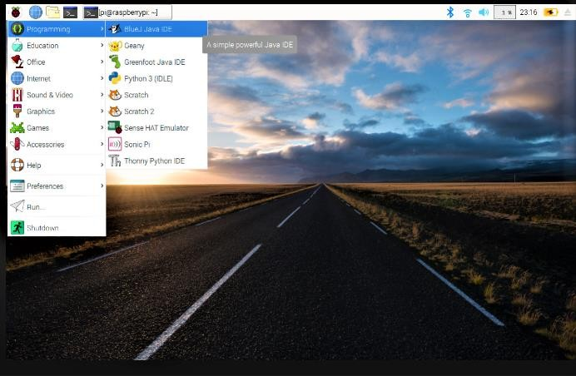

Figure 7: Raspberry PI Operating system Raspbian

* 1. *Python*

Python is a cost free, open source programming language (Python, 2014). Python was chosen for a variety of reasons as it contains many advantages. Python comes installed already on the Raspberry Pi operating system Raspbian. OpenCV is compatible with Python wrappers for easier development. Python has the ability to run operating system commands and can be used for web development.

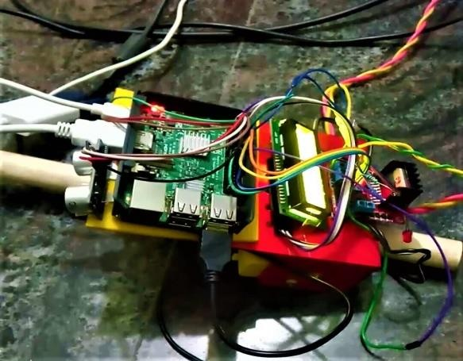

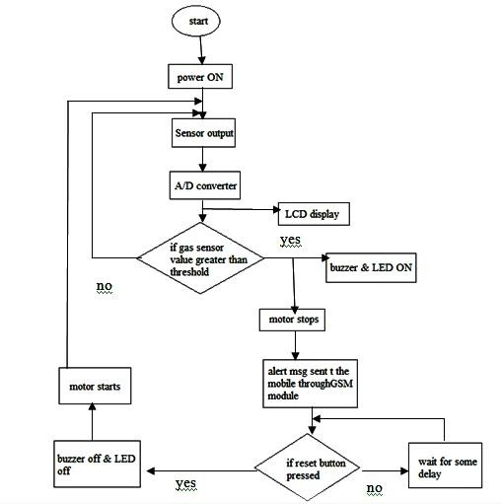Figure 8: Flow Chart of the Gas leakage detector Insect Robot.

The Flowchart of the Gas leakage detector Insect Robot is as shown in Figure 8. A Gas leakage detector Insect Robot has been developed and successfully can detect the gas leakage. The WiFi Module and the MQ135 sensor are initialized. If there is a gas leakage, it is detected by the sensor, which is placed on the robot. The buzzer is turned on indicating the presence of gas leakage. After the detection of the leakage, the robot stops. An alert message is sent to the operator through GSM Module. If there is no gas leakage detected, then no action is performed.

VI. EXPERIMENTAL RESULTS

The software and hardware are combined together to get the complete proposed system. The system is as shown in figure 8

(a) & (b). Testing is important in every system. So this system must be tested in real situation. The gas leakage detection is operated normally. In the figure 9, t he proposed system of gas leakage detector robot is illustrated.

(a)

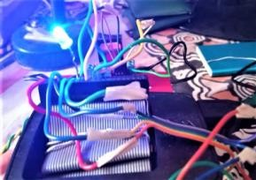

(b)

Figure 8: (a) Robot moving on gas pipe (b) LED gets on when the gas is sensed.

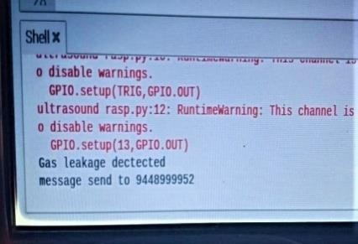

Figure 9: Notification obtained on the users screen

VI. CONCLUSION

The Raspberry Pi-3 has features of inbuilt Wi-Fi and Bluetooth. This proposed monitoring system can be further enhanced by using GSM to send the alert messages to user smart phone by creating mobile Apps. The proposed model is low cost, small in size. The model detects the leakage of the gas using MQ-135 gas sensor using ultrasonic sensor and alerts the consumer about the gas leakage by sending a SMS on user’s mobile phone.

It is observed that both the sensor unit and SMS unit are very well interfaced with the raspberry pi3. The robot works well in normal conditions in detecting the gas leakage. Under normal conditions, the experimental robot is 85% well- organized